BY GROUP 16: JANET SLEIMAN

OLAF MEYER

CALEB SMITH

Multi-threaded web proxy

CSCE 3530

April 23, 2015

# Multi-threaded web proxy

## Summary

The aim of this project is to create a proxy server that alters a user's experience of the web. The proxy should deal with the following features:

* Cache
* Blacklist
* Profanity filter

## Approach

A proxy server acts as an intermediary for requests from clients seeking resources from other severs. Using C socket programming, a proxy server is created that the client can connect to via their web browser. When the proxy server receives an HTTP request for an object from a browser, it generates a new HTTP request for the same object and sends it to a remote server that is hosting the requested object. When the proxy receives the corresponding HTTP response with the object from the remote server, it creates a new HTTP response, including the object, and sends it to the client. The proxy is muti-threaded, so it handles multiple requests at the same time.

## Implementation

Users can connect to the proxy server from a web server using:

<serveraddress>:<port>/<webaddress>' with port = 1357

### cache

The proxy server can cache sites that have already been visited.

The server receives the web address as a GET request from the browser. The proxy then forwards this GET request to the web server. If the site has been accessed before, the proxy accesses a cache directory which has a local copy of the server's response in it and returns it to the client. If it has not been accessed before, then what the web server returns, the proxy server takes into a buffer. The proxy then stores the buffer into a cache file with the name of the website visited in the cache directory.

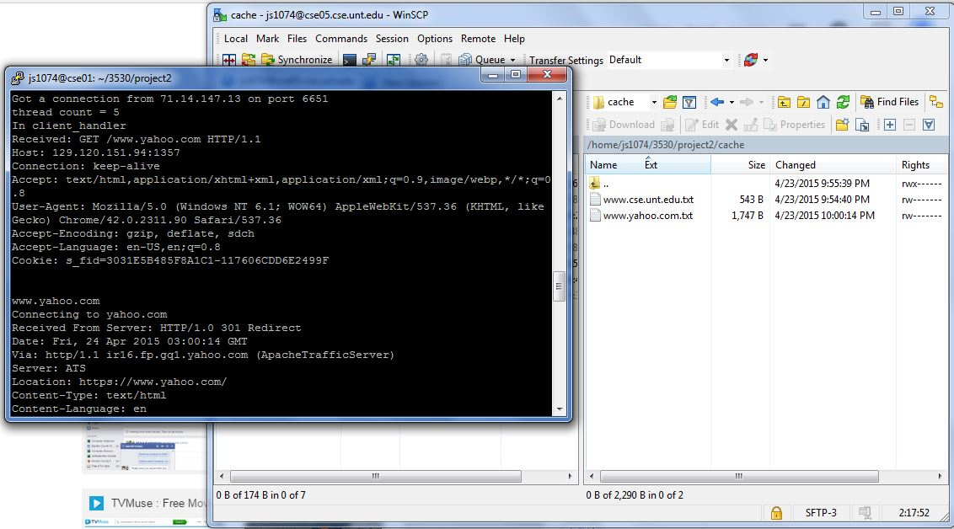

### blacklist

The proxy server can block websites from a given black list that includes the following websites:

[www.facebook.com](http://www.facebook.com)

[www.youtube.com](http://www.youtube.com)

[www.hulu.com](http://www.hulu.com)

[www.virus.com](http://www.virus.com)

Once the user inputs one of the above websites, the web browser will display a cool message saying the site is blocked.

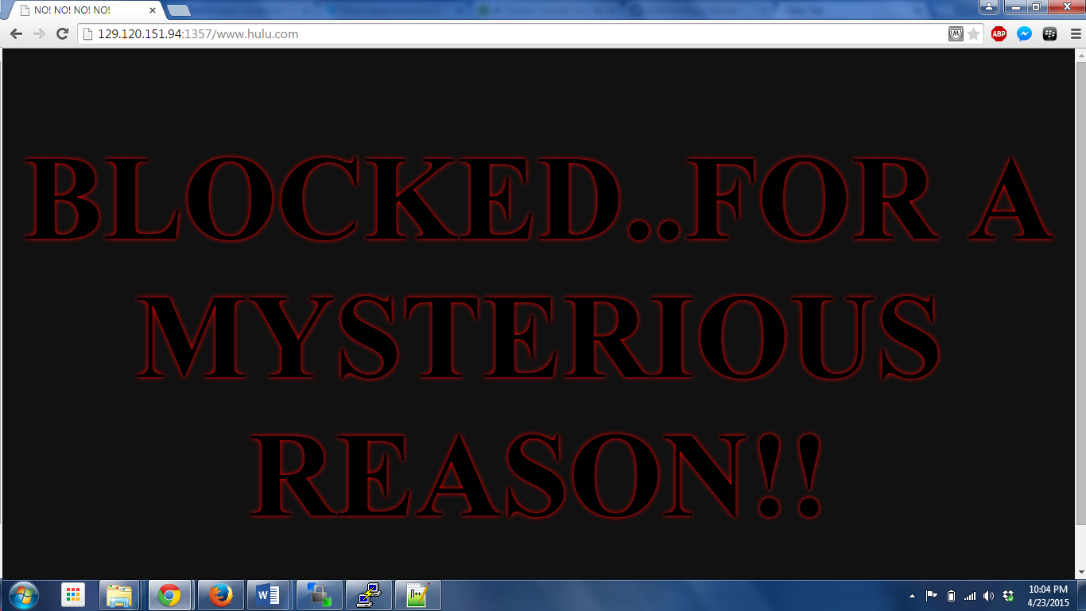

### Profanity filter

Unfortunately, we didn’t have enough time to implement the last feature of the proxy server.